**ASSIGNMENT 2**

**Name: Kandukuri Pavan Kumar**

**Student ID: 700740975**

**Git: https://github.com/pxk09750/Neural-Assignment.git**

**Video:**

https://drive.google.com/file/d/1uCF-BIT30bUKbihYBzbyocjm1bkxYh9s/view?usp=drive_link

**1:**

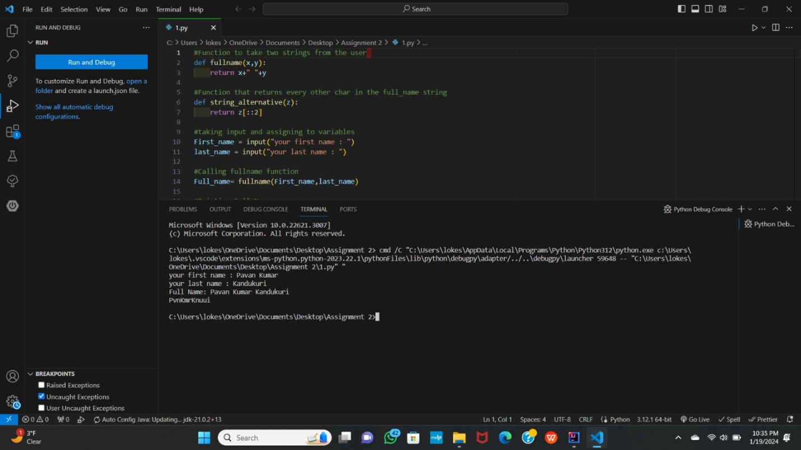

**2:**

**3:**

